Recommendations for Students
Prepare Your Mindset:
- Make a list of what you LIKE and DISLIKE (about jobs, technical skills, classes, yourself, others) realize this list will change and you do not need to show it to anyone. Consider ranking them.
- Keep in mind YOU are unique, YOU have a lot to offer, don’t self-limit yourself, don’t tell yourself ‘no’, let someone else tell you ‘no’. (No one is seeking ‘perfection’ from you, they want your best effort).
- Be open-minded and seek out a variety of opportunities (you don’t know what you don’t know).
- It is OK to not know what you want out of life right now; stay fluid/flexible but not unfocused.
Interacting with Others:
- Knowing when to call, text or email is something you should always stop and think about.
- Talk or write like a lab report (start with you who are, what you are seeking and why you are qualified).
  - Be short in duration and speak clearly. Practice what you plan to say.
  - Then listen, allow them to process what you told them.
  - Aim to have a ‘conversation’; keep it relaxed but professional.
  - Pay attention to your non-verbal movements (eye contact, facial expressions).
  - Ask good questions and if need be clarifying questions.
Job Search:
- Yes! Employers know you have no experience but you have something to offer!!
- Speak up and seek out opportunities. Be PROACTIVE and use all available resources.
- Maintain your professionalism and your calendar. Keep track of ‘who’ you contact and follow up. Do not schedule an interview during class. They will work with your schedule.
- Good time-management is key. It will take time to do your resume, practice for the interview and start a job search.
- See handout on interviewing questions (as a guide) and what employers are evaluating you on.
- Always try to send a thank you email or note, after you interview or meet with someone.
- Always evaluate your interviews and conversations. Pick up on things you did well and where you need to improve.
Let’s Start Now: These are the top 2 things I know I:
Like Dislike
1) ____________________________________ 1) _______________________________________
2 ) ____________________________________ 2) _______________________________________
This is something I feel I do well, is a strength of mine or makes me unique:____________________________
_________________________________________________________________________________________
These are two resources (person, place or thing) I can use to help me in my job search:
1) ___________________________________________ 2) ______________________________________
This is one goal I plan to reach by the end of the current semester:

Who can further assist you in your development?

Career Center: career.charlotte.edu 150 Atkins
- Self-assessment
- Hire-A-Niner, a database that holds jobs, resumes but also has workshop schedules along with interviewing tips, job fair info., resume examples, etc. It is a great FREE tool for all students.

The College of Engineering Career Advisor:
- Ms. Linda A. Thurman (she/her)
Director for Student Professional Development and Employer Relations,
College of Engineering Student Prof. Dev. Advisor & Co-op Coordinator
​​Office: Smith Building, 228F | Direct: (704) 687-5024
lthurman@uncc.edu |​ pd.charlotte.edu
LinkedIn or Twitter @L_ThurmanENGR for updates and announcements!
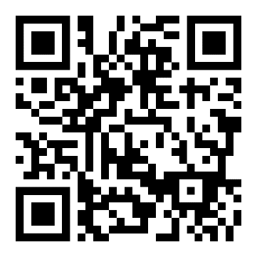
The Office of Student Development and Success (OSDS): engr.charlotte.edu Smith 228
- offers programs to support our students: ENGAGE ME, WE ENGAGE, MAPS, Leadership Academy and unique employer, alumni and student engagement opportunities! ​ ​

~~~~~~~~~~~~~~~~~~~~~~~~~~~~~~~~~~~~~~~~~~~~~~~~~~~~~~~~~~~~~~~~~~~~~

Stay positive about yourself. Stay position about bad situations. Own your “mishaps” but always continue learning. Set your goals and revisit them often and make the adjustments as needed. There is no one or right way to ‘do college’ or to ‘find a job’.

